Q. Show that following problems are in NP: (Hint: only need to show there is polynomial time verification algorithm for decision version)
1. MST: there are polynomial time solvable algorithm. For any decision problem asking is there an MST of total weight at most k? Just apply any of (Prim’s/Kruskal’s etc) polynomial algorithm and verify if the cardinality of solution is at most k. Thus the optimization algorithm is same as verification algorithm here.
Given a possible solution of weight k- verify that it is a spanning tree?
2. Independent Set:given a possible solution of size k, just need to verify there’s no edge in common. Time complexity=?
With adjacency matrix:k*(k-1)*O(1), constant in terms of n.
With adj list: a loose bound is O(k*n) (each list can be n elements long)
3. 3-SAT: n variables, is there a satisfying truth assignment so all k clauses are satisfied simultaneously?
Verification: given a truth assignment, it can be verified by plugging into the given formula and verifying all clauses in time polynomial in n(variables) and k(clauses)
4. Set packing: Given a packing of size k, check pairwise intersection in time=?
Ans. Construct a hashtable of boolean values for all elements-element seen or not. Mark all unseen initially. Iterate over all elements of each set and verify it has not been seen so far and mark it seen.
(3*4=12)

Q. Consider A<=B<=C<=D. A polynomial time algorithm for which of these will guarantee polynomial time algo for all. Explain briefly (3)

Q. Reduce an instance of vertex cover to set cover complete with converting back the solution. (6)

Q. Assuming P!=Npwhich of following is true?
A) NPC=NP
B)NPC intersection P=phi
C)NP hard=NP
D) p=NPC

Q. Let S be an NPC problem and Q and R be other two problems not known to be in NP. Q is <=_{p} S and S
<=_{p} R. Which of following is true
A. R is NPC
B. R is NP hard
C. Q is NPC
D. Q is np hard

Q. Let X be a problem that belongs to the class NP. Then which one of the following is TRUE?
A | There is no polynomial time algorithm for X.
B | If X can be solved deterministically in polynomial time, then P = NP.
C | If X is NP-hard, then it is NP-complete.
D | X may be undecidable.

Q. The problem 3-SAT and 2-SAT are
A | both in P
B | both NP complete
C | NP-complete and in P respectively
D | undecidable and NP-complete respectively

Q. Which of the following statements are TRUE?
(1) The problem of determining whether there exists a cycle in an undirected graph is in P.
(2) The problem of determining whether there exists a cycle in an undirected graph is in NP.
(3) If a problem A is NP-Complete, there exists a non-deterministic polynomial time algorithm to solve A.
A | 1, 2 and 3
B | 1 and 3
C | 2 and 3
D | 1 and 2

Q. Which of the following is true about NP-Complete and NP-Hard problems.
- If we want to prove that a problem X is NP-Hard, we take a known NP-Hard problem Y and reduce Y to X [All in NP<=_{p}NP hard]* (NP hard contains NPC but not necessarily others in NP, so NPhard problem may/maynot be in NP)
- The first problem that was proved as NP-complete was the circuit satisfiability problem.*
- NP-complete is a subset of NP Hard
- All of the above
- None of the above

Question 8
Suppose a polynomial time algorithm is discovered that correctly computes the largest I.S. in a given graph. In this scenario, which one of the following represents the correct Venn diagram of the complexity classes P, NP and NP Complete (NPC)?
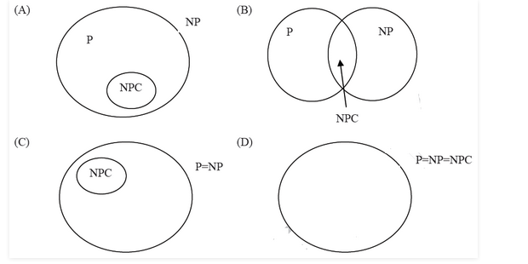
A | A
B | B
C | C
D | D

Question 9
Consider the decision problem 2CNFSAT: It is
A NP-Complete.
B solvable in polynomial time by reduction to directed graph reachability.
C solvable in constant time since any input instance is satisfiable.
D NP-hard, but not NP-complete.

Question 10
Let SCNF₃ be the problem of finding a truth assignment satisfying a 3CNF formula and DCNF₃ be the problem of determining if a satisfying assignment exists for this formula. Which one of the following is true?
A | Both DCNF₃ and SCNF₃ are NP-hard
B | SCNF₃ is NP-hard, but DCNF₃ is not
C | DCNF₃ is NP-hard, but SCNF₃ is not
D | Neither DCNF₃ nor SCNF₃ is NP-hard

Question 11
Ram and Shyam have been asked to show that a certain problem Π is NP-complete. Ram shows a polynomial time reduction from the 3-SAT problem to Π, and Shyam shows a polynomial time reduction from Π to 3-SAT. Which of the following can be inferred from these reductions ?
A | Π is NP-hard but not NP-complete
B | Π is in NP, but is not NP-complete
C | Π is NP-complete
D | Π is neither NP-hard, nor in NP
Question 12
Consider the following two problems of graph.
1) Given a graph, find if the graph has a cycle that visits every vertex exactly once except the first visited vertex which must be visited again to complete the cycle. : Hamiltonian circuit
2) Given a graph, find if the graph has a cycle that visits every edge exactly once. Which of the following is true about above two problems. : Euler circuit
A | Problem 1 belongs NP Complete set and 2 belongs to P
B | Problem 1 belongs to P set and 2 belongs to NP Complete set
C | Both problems belong to P set
D | Both problems belong to NP complete set
Question 13
Consider two decision problems Q1, Q2 such that Q1 reduces in polynomial time to 3-SAT and 3-SAT reduces in polynomial time to Q2. Then which one of the following is consistent with the above statement?
A | Q1 is in NP, Q2 is NP hard
B | Q2 is in NP, Q1 is NP hard
C | Both Q1 and Q2 are in NP
D | Both Q1 and Q2 are in NP hard

Question 14
A problem in NP is NP-complete if
A | It can be reduced to the 3-SAT problem in polynomial time
B | The 3-SAT problem can be reduced to it in polynomial time
C | It can be reduced to any other problem in NP in polynomial time
D | some problem in NP can be reduced to it in polynomial time

Question 15
For problems X and Y, Y is NP-complete and X reduces to Y in polynomial time. Which of the following is TRUE?
A | If X can be solved in polynomial time, then so can Y
B | X is NP-complete
C | X is NP-hard
D | X is in NP, but not necessarily NP-complete
Question 16
The problems 3-SAT and 2-SAT are
A | Both NP-complete
B | Both in P
C | NP-complete and in P, respectively
D | Undecidable and NP-complete, respectively

